This was a year of many endings and some beginnings.

Gary started the year working with a new company, Tibco Software. Actually, he stared mid-December 2006.

Carolyn was pretty ill in March and April with something called “Paralytic Illius”, which is not an episode name from Man from U.N.C.L.E., but is an intestinal disorder. She decided in the end she was safer staying home than convalescing in the hospital, and did completely recover. She is continuing her work helping very young children with speech disorders.

Gillian returned to COD, the local junior college, where she is continuing her studies.
Ryan finished up middle school and in late August began his high school career at Naperville North High School. He’s doing well and enjoys volunteering back stage on tech crew.

In early August Tibco sent Gary back to Palo Alto for a week to meet with his boss – who only managed to find about 3 hours during the week to actually see him. Meanwhile, never one to pass up a good opportunity, Carolyn accompanied Gary. They only saw each other occasionally, though, because although the folks at Tibco did take Gary out for dinner each night Carolyn was invited to not join them. But we got to see Barry over the weekend, and during the week Carolyn got to spend time with her brother and his family (and some time with Barry and other friends, too) and enjoy the hotel amenities (pool etcetera) that Gary could not.

Later in August, Carolyn & Karen, Gillian & Sarah, and Ryan & Judson spent a long weekend enjoying the sand and water in Michigan. Shortly after that Gary took Suki and spent a long weekend at a doggie camp, scootering and swimming and just hanging out. It was great fun, and amusing to see Suki actually tired from so much exercise.

In September just before labor day we went up to visit our friends the Beckers in Madison, Wisconsin. We made quite a weekend of it; first the four of us went to a water park overnight, then we stayed with the Beckers and went out on their boat. A wonderful time was had by all (as usual).

When we returned to Lisle we discovered that our friend and Suki’s breeder Sharon was gravely ill. Gary spent most of the next week or two arranging temporary care for her 6 dogs and then completed the planned adoption of Zephyr, a Samoyed, to round out his mushing team. A few weeks later one of the founders of the mushing club suddenly and unexpectedly insisted Gary leave the club because of Gary’s long standing refusal to use punishment (aversives) while training his dogs. Gary dealt with a minor medical crisis with his mother, who remains not dead – too demented to remember anything, unable to speak or care for herself. Two weeks later Sharon died, and then the Kimber’s son Alex died. Gary went to 2 memorial services that weekend. He was then fired from his job, the second victim of a turf war. At the end of November Gary & Carolyn attended Deb Russcol’s 29th annual post-thanksgiving party and saw a lot of old friends. We took some time there to remember Kirk Pamper, an acquaintance of Gary’s from high school and a good friend of Deb’s, who died a few days earlier. Just before we printed this letter (in mid-December) we learned that Carolyn’s friend Beth Neuman died.

Carolyn took some time to fly over to Shotton to help her mother through her knee replacement surgery. Things went well. With Bill no longer able to come to visit us in the US (because he can’t get private health insurance) we decided to spend Christmas in Wales with Bill & Pat, so we are looking forward to that. We are leaving 21 December. Gary & Ryan are returning 1 January (yup, new year’s day, airport should be pretty empty) and Carolyn & Gillian are returning 5 January.

Zephyr has been working out wonderfully well. He and Suki play constantly, and even old Cosmo sometimes joins in the fun. Gary has been training Suki & Zephyr to scooter, and entered a race (up in Fond Du Lac) in early December. They did well, out running some of the husky teams. Gary and Mike Elder have started a scootering club that meets when the weather allows (another beginning). Suki, by the way, remains the only known competitively mushing collie in the Midwest.

So this year ends on a somewhat blue note, with Gary looking for a new job. Those of you who can remember back to what went down for Gary back in 1981 can imagine how he is feeling being out of work, but everyone’s health is good, the kids are doing okay in school. We hope the year has been kind to everyone.

We have gone out and purchased our own domain name, so if we leave Comcast our new email address won’t have to change. Please make a note of the new email addresses, as they are unlikely to ever change again. You can reach us at:
Gary@Hughes-Fenchel.net
Carolyn@Hughes-Fenchel.net
Gillian@Hughes-Fenchel.net
Ryan does not presently want an email address. Our existing addresses (gghf@comcast.net, cphf@comcast.net, darkhazel@comcast.net) will continue to work for the foreseeable future. Our home page can be viewed at www.Hughes-Fenchel.net . Gary in particular would love to hear from old friends, so send some email when you have the time.

The Hughes-Fenchels, Christmas, 2007

(This year we had to rewrite the letter a couple of times. Draft one sounded like it was written by Marvin the Paranoid Android … with apologies to Douglas Adams)

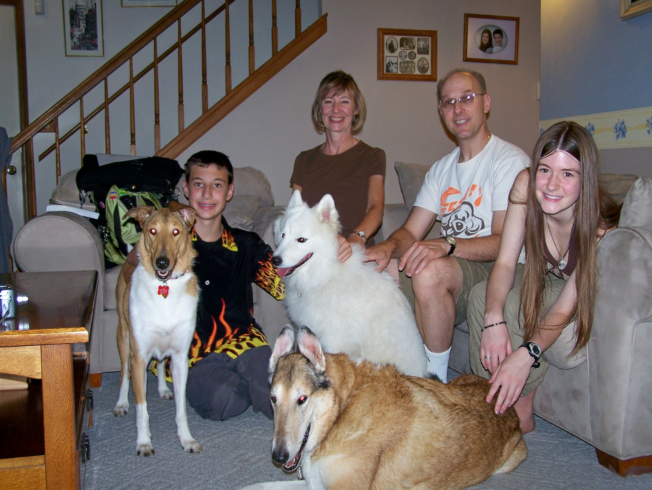

This picture was taken moments after we signed the adoption papers for Zephyr. If you look very closely you can see he is wearing a choke collar – we sent the collar back with the signed papers and gave him a limited slip collar!

